Beyond **Black-Scholes**

Specify a model (e.g. geometric Brownian motion)

* A discrete model.
* Consistency between BTM and PDE

Three methods:

* PDE
* BTM
* Monte-Carlo Simulation

Under the Black-Scholes framework.

* American style
* Multi-asset options (multi-dimensional Ito lemma)
* Barrier options
* Asian options and lookback options
* Shouting options
* Forward start options
* Compound options

**Beyond Black-Scholes**

* Implied volatility and volatility smile phenomenon
* Improved model:
  + Local Vol
  + Stochastic Vol
  + Jump-diffusion

**Monte Carlo Simulation With GBM**

To calculate the [value at risk](http://www.investopedia.com/terms/v/var.asp) (VaR) of a portfolio, we can run a Monte Carlo simulation that attempts to predict the worst likely loss for a portfolio given a [confidence interval](http://www.investopedia.com/terms/c/confidenceinterval.asp) over a specified [time horizon](http://www.investopedia.com/terms/t/timehorizon.asp) - we always need to specify two conditions for VaR: confidence and horizon.

**Where to Start**A Monte Carlo simulation is an attempt to predict the future many times over. At the end of the simulation, thousands or millions of "random trials" produce a distribution of outcomes that can be analyzed. The basics steps are:

We will use the geometric Brownian motion (GBM), which is technically a Markov process. This means that the stock price follows a [random walk](http://www.investopedia.com/terms/r/randomwalktheory.asp) and is consistent with (at the very least) the [weak form](http://www.investopedia.com/terms/w/weakform.asp) of the [efficient market hypothesis](http://www.investopedia.com/terms/e/efficientmarkethypothesis.asp) (EMH): past price information is already incorporated and the next price movement is "conditionally independent" of past price movements.  
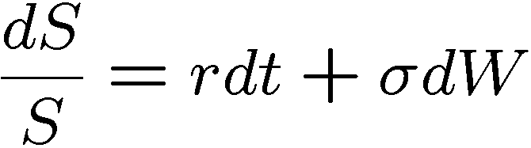  
  
2. Generate random trials

To illustrate, we've [used Microsoft Excel](http://www.investopedia.com/university/excel-finance/) to run 40 trials.

|  |  |
| --- | --- |
| CT-MonteCarlo4ra1.gif | CT-MonteCarlo45ra2.gif |

|  |
| --- |
| Figure 2: Geometric Brownian Motion |

3. Process the output

The simulation produced a distribution of hypothetical future outcomes. We could do several things with the output. If, for example, we want to estimate VaR with 95% confidence, then we only need to locate the thirty-eighth-ranked outcome (the third-worst outcome). That's because 2/40 equals 5%, so the two worst outcomes are in the lowest 5%.  
  
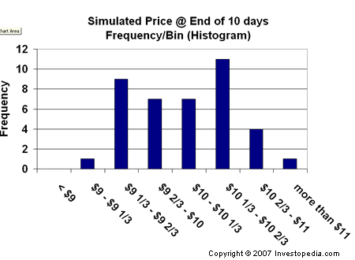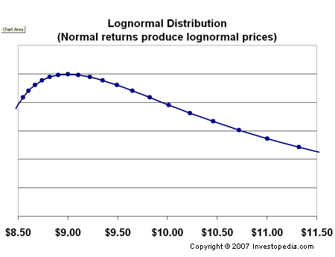

* Price *returns* are normally distributed.
* Price *levels* are log-normally distributed.

**VaR** (value at risk) modeling determines the potential for loss in the entity being assessed, as well as the probability of occurrence for the defined loss. VaR is measured by assessing the amount of potential loss, the probability of occurrence for the amount of loss and the time frame.

There is no standard protocol for the statistics used to determine asset, portfolio or firm-wide risk. For example, statistics pulled arbitrarily from a period of low volatility may understate the potential for risk events to occur, as well as the potential magnitude. Risk may be further understated using normal distribution probabilities, which generally do not account for extreme or black swan events.

Since [value at risk](http://www.investopedia.com/terms/v/var.asp) is affected by the [correlation of investment positions](http://www.investopedia.com/video/play/correlation/), it is not enough to consider an individual investment's VaR level in isolation. Rather, it must be compared with the total [portfolio](http://www.investopedia.com/terms/p/portfolio.asp) to determine what contribution is makes to the portfolio's VaR amount.

**Marginal VaR**

The additional amount of risk that a new [investment](http://www.investopedia.com/terms/i/investment.asp) position adds to a portfolio. Marginal VaR (value at risk) allows risk managers to study the effects of adding or subtracting positions from an investment portfolio. Since [value at risk](http://www.investopedia.com/terms/v/var.asp) is affected by the [correlation of investment positions](http://www.investopedia.com/video/play/correlation/), it is not enough to consider an individual investment's VaR level in isolation. Rather, it must be compared with the total [portfolio](http://www.investopedia.com/terms/p/portfolio.asp) to determine what contribution is makes to the portfolio's VaR amount.  
  
**Incremental Value At Risk** The amount of uncertainty added to or subtracted from a portfolio by purchasing a new investment or selling an existing investment. Investors use incremental VaR to determine whether a particular investment should be undertaken, given its likely impact on potential portfolio losses. 

**Market risk**, also called "[systematic risk](http://www.investopedia.com/video/play/systematic-risk/)," cannot be eliminated through diversification, though it can be hedged against.Sources of market risk include recessions, political turmoil, changes in interest rates, natural disasters and terrorist attacks.

**Country risk** is a collection of risks associated with investing in a foreign country. These risks include [political risk](http://www.investopedia.com/terms/p/politicalrisk.asp), exchange rate risk, economic risk, [sovereign risk](http://www.investopedia.com/terms/s/sovereignrisk.asp) and transfer risk, which is the risk of capital being locked up or frozen by government action. 